Cromarty East Church

Cared for by

The Scottish Redundant Churches Trust

Education Support Pack

March 2009

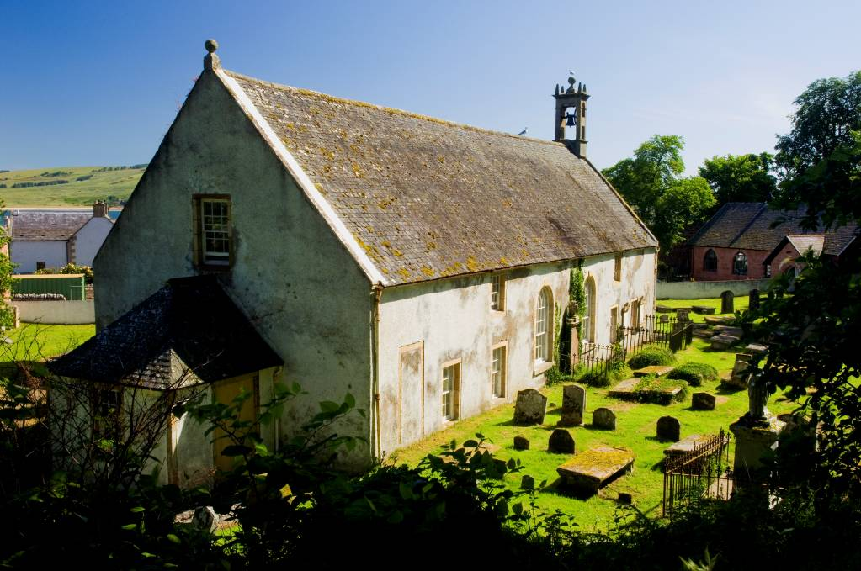




By

Emma Griffiths

Building Learning
Heritage Education, Training & Interpretation

107 Willowbrae Road
Edinburgh EH8 7HN
0131 661 2837
077 080 70 22

www.BuildingLearningScotland.co.uk

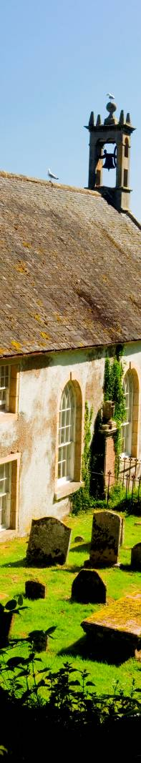
Contents | Page
Introduction | 4
Building Learning | 4
The Scottish Redundant Churches Trust | 4
What is happening at Cromarty East Church?  - Why is the church so important?  - Why is it important to keep old buildings?  - How are old buildings different to modern ones?  - During the conservation period, who will be on site, and what sort of things will they be doing? | 5
How can I link a visit to Cromarty East Church to my class work? | 10
What can we do before we visit? Some ideas. | 11
What sort of things could we do on a visit? | 12
What can we do after a visit? More ideas | 13
Practical hints for planning your visit | 14
Summary | 14
Glossary | 15
Further reading and resources | 17
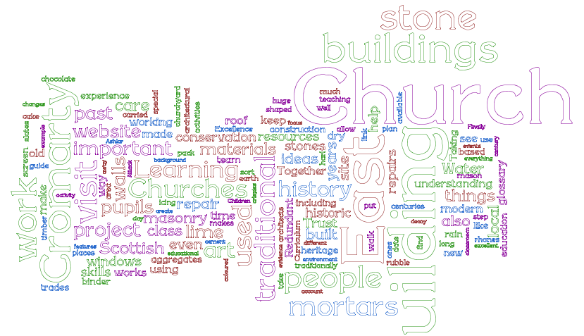

Introduction

This pack is intended for teachers, or others leading educational visit to Cromarty East Church. It explains the background to the programme of works to repair and conserve the building, which began in 2008, and is expected to last up to two years.

This pack also provides some background to the organisation that now cares for the church. It then makes some suggestions for activities prior to a visit; what to expect, and do, when visiting the site; and suggests some follow up activities. Finally, there are a few hints for planning a school trip or visit. Words in italics are explained in the glossary.

Building Learning

Building Learning is the education consultancy of Emma Griffiths. Degrees in history of art, and architectural conservation are an unusual combination with hands on experience in education. However, with extensive experience in the built heritage field, as well as in the primary classroom; teaching adults; and in community education; Building Learning has a good perspective on buildings, and on learning!

This guide for teachers and others leading educational visits, has been written by Building Learning, and was commissioned by the Scottish Redundant Churches Trust

The Scottish Redundant Churches Trust

The Scottish Redundant Churches Trust (SRCT) was established in 1996 to secure the future of nationally important churches threatened by closure. The Trust takes churches into care to ensure they survive for enjoyment, use and learning. The buildings taken into care are special because they represent the most important examples of their types, often by Scotland’s finest architects and craftsmen, and reflect an important part of the national heritage.

Most of the churches taken into care need extensive specialist repairs and conservation. Churches in care are given a new lease of life, and can become places where communities can gather, places for learning or reflection, and places of worship where occasional services can be held, including weddings and funerals.

Find out more about them at http://www.srct.org.uk/

What is happening at Cromarty East Church?

- Why is Cromarty East Church so important?
- What will happen during the project?
- Why is it important to keep old buildings?
- How are old buildings different to modern ones?
- Who will be on site, and what will they be doing?

Why is Cromarty East Church so important?

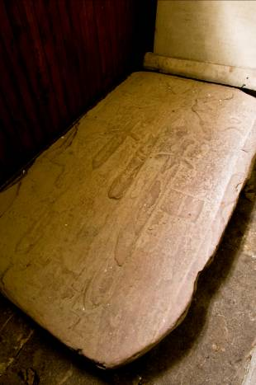
The East Church is a former parish church central to the history of the town and the people of Cromarty. There is written evidence of the building being used for worship from 1560, but it is very likely that it was in use before that date.

Evidence for this includes grave slabs which with carvings generally agreed to date from the fourteenth or fifteenth centuries.

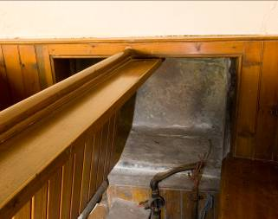
The East-West orientation of the oldest part of the building also indicates that it dates from at least the fifteenth century, and quite possibly from the formation of the parish in the twelfth or thirteenth century. When originally built, the church would have been a slender rectangle, with an altar at the east end, symbolically facing the sunrise. This was the common pattern for Medieval churches.

At the east end of the church, in the altar area, there is a opening in the wall called an aumbry, which would have been used like a cupboard to store Mass vessels pre-1560 when the national faith was Roman Catholic.

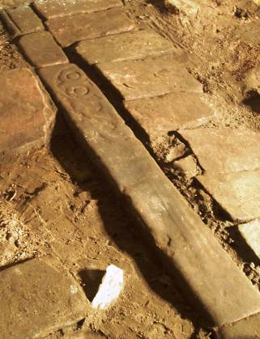
This evidence provided the sole indication that the East Church is Medieval in origin before restoration work began in late 2008. Excitingly archaeological work within the church revealed an altar kerb at the east end of the church. Part of this was a carved stone 14th or 15th century in origin, and thought to be a former gravestone sliced in half lengthways.

The present T-shape of the church reflects changes to the building over time. These would have taken place for many different reasons: a larger congregation, changes in church politics, and changing tastes and fashions too. At the East Church, a north aisle was added, as well as lofts and porches.

The changes to the building reflect changes in religious practice and society, the work of local craftsmen, notable local characters, and tell the story of the community in Cromarty over the centuries.
What will happen during the conservation project?

The works at Cromarty East Church will ensure that all aspects of the building are returned to good repair. In this way, a building, which has already been documented as a place of worship for well over 4oo years, can hopefully survive for at least as long again.
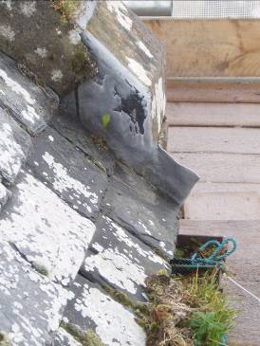
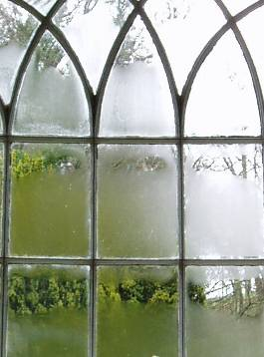
Water getting into buildings is often the cause of most major problems, like damp and dry rot. If wooden roof beams begin to rot, then there can be serious structural failures or even collapses. Water can get into the building through rain seeping through walls where rhones are blocked, through gaps in pointing, breaks in harl finishes, or where slates are missing. Water can be drawn up into walls too, if the ground around the building isn’t properly drained. At the East Church, the steep slope behind the site, raised ground levels outside, and earth floors inside, mean that the building is prone to damp. Part of the restoration work at the church has been to put in effective drainage.

Carrying out regular maintenance to clear rhones, replace slipped slates, and repair harl is important. Spending small amounts of money each year on regular maintenance saves having to carry out much bigger, more expensive repairs in the longer term.

The poor condition of the East Church is the result of too little maintenance over many years. And unfortunately some of the repairs that were carried out were done at a time when cement was thought to be the solution for damp buildings. We now know that in fact a concrete harl only makes matters worse. It means that any damp that gets into the building is unable to escape, in architectural parlance the building is unable to ‘breathe’.

The current repair of the East Church is using that knowledge to reduce damp in the building. The work is carried out by skilled craftsmen, with expert architectural advice and the right materials. The worksite team will include masons, joiners, glaziers, slaters, plumbers, plasterers and painters. There is an acknowledged shortage of trades people with appropriate skills to work on historic buildings. The conservation of the church will allow people to gain traditional building skills as the work takes place.
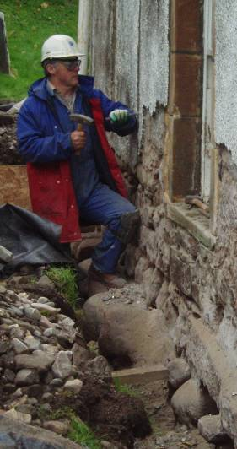
Measures to reduce damp and repair the church include:

- New drains around the church to carry water away from the building and help to keep it dry.
- Removal of cement-based wall coverings inside and outside stop them trapping moisture inside the walls, and replacement by traditional lime-based harl outside, and lime plaster inside, to allow the building to breathe.
- Stripping the roof of all its slates, the impermeable roofing felt replaced with a breathable one and repairs carried out to the supporting timbers supports beneath. As many slates as possible are reused, and only damaged ones discarded and replaced with new, so that the character and appearance of the building does not change.

Increasing public, and especially local, appreciation and understanding of Cromarty East Church, and its significance, is another aim of the project. Educational visits help more people understand why the church is important, and learn about some of the techniques used to repair historic buildings.

Why is it important to keep old buildings?

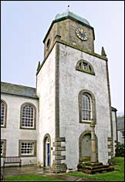
The contribution that the historic environment makes to our well being isn’t easy or quick to define. Contrasts can help. Which would be a more pleasant walk on a sunny day at the weekend? A circuit around an industrial estate, the units typically clad in grey profiled sheeting with plastic signs and, perhaps, to catch the eye, some primary coloured rainwater down pipes. Few pavements for walking, mainly flat tarmac parking bays, windblown litter, and everything on a huge, impersonal scale.

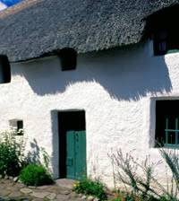
Contrast this with a stroll along Cromarty’s Church Street. Admire the crowstepped gables, notice carved date stones set into the traditional harl finishes. Look at the roofs: from the thatch of Hugh Miller’s Cottage, to the traditionally Scots slated roofs. Timber sash and case windows use technologies and materials that have survived centuries and give character to the buildings, like eyes in a face. Closes, paths and lanes give glimpses of the sea or lead intriguingly off to private courts and gardens, while at ground level, cobbles and setts add again to the character of this charming historic street. Which walk would you choose?

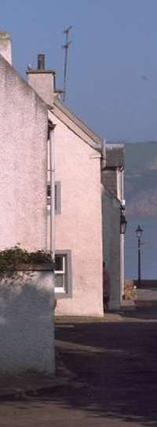
The historic environment can stir feelings within us, of awe, affection, humour, security, and pride. We can marvel at the skill of masons, and see the marks of their chisels in stone, which have sometimes endured centuries. From old buildings, we can learn about the past, what happened and why, sometimes even learn how to improve things, or even re-learn things we have forgotten: like masonry skills. Buildings are stories in stone: about people, and how they chose to make their homes, what they thought was important. Over time, different owners think different things are important. Sometimes simply bigger families mean more space is needed. Fashions, for example, in windows, can lead to drastic changes too, and not always for the better!

How are old buildings different to modern ones?

Traditional forms of construction, that is, the way most buildings were actually put together before the 20th Century, generally used materials that were easily available locally. For example, some of the older buildings in Inverness are of honey coloured sandstone, sourced from quarries in the area. Streets in Aberdeen are defined by the crisply profiled granite found in Scotland’s North East. Many of Cromarty’s buildings, including the East Church, are built from red sandstone.

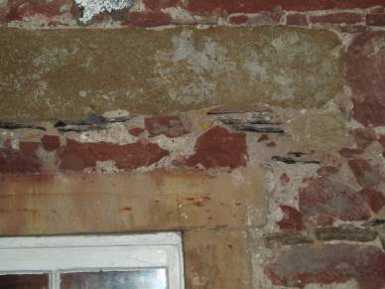
Scots slates, clay pantiles, lime washes and harls also characterise historic buildings in Scotland, and all of these materials can be sourced in the natural environment. The basic form of most traditional construction consists of masonry walls, that is, stone either in its random, naturally occurring shapes, known as rubble, or shaped by stone masons to varying levels of regularity. Ashlar is the name given to stone shaped into uniform rectangular blocks.

The joins between the stone blocks, whether rubble or ashlar, were traditionally filled with a paste called a mortar, made with lime. Lime mortars allow rain to be absorbed and to dry out again in almost exactly the same way as stone, which is important. If water falls onto the face of a stone, works its way down through the block, but then meets a waterproof layer at the joint, it can make the stone start to crumble away. The process takes some years, but is irreversible. If left unchecked, it can damage a building beyond repair.

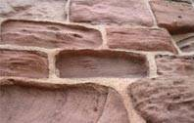
Modern buildings are made from modern materials, and stone tends to be used as a wallpaper, in thin slabs cladding a separate structure which does the job of holding up the building. If modern cement based mortars, which are waterproof, are used with modern materials, it isn’t a problem. But if cement mortars are used in traditionally constructed walls, where the stones play a structural role, then it can cause very serious problems in the medium and long term. The stone can decay and crumble away, leaving the cement pointing standing proud at the stone joints, ready to trap even more rain, and so further accelerate the decay process.

Who will be working at the East Church, and what will they be doing?

Architects, engineers, quantity surveyors
Architects have decided what repairs are needed at the East Church, and how they should be carried out. Engineers will work with the architects to make sure that the structure of the building (foundations, walls, roof, ceiling and floor) is strong and safe. Quantity Surveyors are responsible for keeping records of how much everything costs, including building materials, scaffolding, fees and wages. These people are known as the design team, or professional team.

Archaeologist, historian, conservation adviser
Also working on the project are an archaeologist, a historian, and a conservation adviser. They have researched the East Church and know what makes it an important part of our heritage. They give guidance about the work being carried out, record things that are found, and gather new evidence to help give a better understanding of the history of the building. The archaeologist has special responsibility for uncovering, protecting, and recording things below ground, including burials and artefacts that are discovered during the course of work.

Conservators
The project involves conserving not only the building, but also many of the things in it, including the organ, furniture, painted panels (hatchments), and a medieval carved stone. Work on these items must be carried out by highly-trained specialists with a great deal of experience. These people are known as conservators.

Contractors
The largest team working on the church are the contractors, people with expertise in different building trades such as masonry, joinery, and roofing. The contractors selected for the job were chosen because of their skills and experience with traditional buildings.
How can I link a visit to Cromarty East Church to my class work?

A visit to Cromarty East Church, especially if linked to some class based work, meets the aims of working with a cross curricular theme, and developing the four capacities of the Curriculum for Excellence: Successful Learners, Confident Individuals, Responsible Citizens, and Effective Contributors.

The Taking Learning Outdoors initiative (Taking Learning Outdoors: resources for outdoor education) describes the value of outdoor learning. It states that the Curriculum for Excellence (CFE) recognises that learning is embedded in experience. By taking learning outdoors we remove the barriers that the traditional classroom can put up between young people and first-hand, real-life experiences. Outdoor learning is hands-on and direct, and the knowledge that pupils gain from it is real, first-hand and unforgettable.

Below is a grid with some of the outcomes from the Curriculum for Excellence, and the draft subject guidance, with suggested links and themes.

CFE subject | Sub-topic | Second level, outcome reference | Abreviated main theme or idea of the outcome | On site, focus visit on…
Science | Materials, properties and uses | SCN 232X | Investigate properties of a material, evaluate its effectiveness for purpose | The mason building repairs with lime mortars
Social Studies | People, past events and societies | SOC 201A | Explore places, investigate artefacts and discuss the past to interpret historical evidence, build a picture of Scotland’s heritage | The church and churchyard
 | People, past events and societies | SOC 202B | Investigate a Scottish historical theme to discover how actions of an individual shaped Scottish Society | The church and churchyard
 | People, past events and societies | SOC 204E | Describe the contribution individuals from the past made during their lives, locate them in time, explain influence of their actions | Focus on Hugh Miller, examples of his stone mason work in churchyard, or George Ross, lawyer, major philanthropist and owner of Cromarty Estate from 1760s.
What can we do before we visit? Some ideas
See the section on linking to class work above for background and context too.

1. Art ideas

A significant element of the project to repair the East Church is the training in traditional building skills. This will involve repairs to traditional masonry walls.

The link below is to the Irish art education website, I am an artist. It has clear, concise suggestions for a series of art lessons, beginning with drawing, moving on to paint and colour, print, clay, construction and finally, fabric and fibre. Each lesson is inspired by walls, and there are general ideas for how to tackle each medium. In addition, there is a short (6 minute) video of pupils working on the various ideas: using viewfinders, taking rubbings, making collages and so on.

http://www.iamanartist.ie/projectideas/walls.html#top

Even if there is only time for one of the art lessons inspired by walls before the visit, the exercise of visually recording and taking time to really look at a wall will help the pupils understand what they see at the church much better.

2. Understanding Traditional Construction: food parallels!

Historically, buildings were built of solid masonry, and the joints between the stones filled with lime-based mortars. Pupils could be helped to understand this by a parallel of a cake, sandwiched together by icing. Without icing the cake layers would hold together at first, but, as more and more layers were built up, it would become increasingly wobbly. Icing, like mortar, glues the layers together, giving it stability.

In traditional masonry construction, the mortars behave in the same way as the stones when they become wet with rain, and dry out with wind and sun. Mortars have equal strength to stones too, much the same as the cake and icing! A rain drop of water could enter the stone, trickle down within the stone, and end up evaporating through the face of the mortar joint. Juice spilt on a slice of cake would, in the same way, work its way down through cake and icing layers making them soggy.

The pupils could then learn more about mortars. Mortars consist of a binder, and aggregates, usually sand or gravel. In traditional mortars, the binder is lime based, and the aggregates can be anything from brick dust, sand, ground up shells, to tiny pebbles. Pupils could continue the food analogy, by making chocolate crispy cakes, understanding that the melted chocolate is the binder, and the rice crispies constitute the aggregates! Variations occur regionally in mortars; shells being added in seaside locations for example. Children could consider variations to their mortars: crushing the rice crispies, adding crushed digestive biscuits, raisins, dried coconut or other nuts – assuming there are no nut allergies or other food issues! Variations to the binder could also be considered: adding Mars bars to the melting chocolate would make it more pliable, and make the set less rigid. This could be a useful quality for mortars in certain conditions. The mortars used all over Cromarty probably had shell in the mix, as it would have been freely available from the shore. If your school building is traditionally built, pupils could go outside and look at pointing. They might be able to see some traditional mortars, possibly even identify the aggregates.

3. Understanding the location

Google Earth
Cromarty East Church has an interesting geographic location. Pupils may be helped in their understanding of the area they are going to visit by looking first on Google Earth, then zooming in on the peninsula, and finally, on the church. Beside a huge grey looking field, the T-shape of the building, set within the churchyard, is quite clear. With North indicated on the screen, it is easy to point out the East-West orientation of the original structure.

If there isn’t internet access, or a whiteboard, try saving a screen shot of a close view (press control, alt and print screen buttons all at the same time, then control and V once a blank word document has been opened. An image will appear, as if by magic, of the Google Earth screen.) Project this, if possible, in the classroom, or let children take turns at looking at it on a class computer screen.

A further option would be to access some of the many images from the Cromarty archive website. There are wonderful historic maps, and pictures of recent and historic events.

With either of the options above, the activity could be developed to work on map skills. For example, use a map of Cromarty and colour code buildings associated with Hugh Miller or George Ross.

What sort of things might happen on a visit?

The Community & Education Officers (CEOs), whose details are below, are available to guide visits to the church. Please make contact with them in advance, and they will help you get the most out of your visit.
The stage of the works at the church will have an effect on what can be seen. If the entire building is under scaffold, it may be helpful to plan a visit for a time when there is better access and visibility. However, there is a desire amongst all the team working on the church to share knowledge and understanding of craft skills, so there is always plenty of interest to see and do.

The CEOs can also help with practical advice and arrangements such as somewhere to eat packed lunches, and where to find toilets. To arrange your visit please:

- telephone: Caroline Vawdrey – 01349 877625, David Alston – 01381 600243
- email: info@eastchurchcromarty.co.uk
- Or write to: 51 Church Street, Cromarty, Ross & Cromarty, IV11 8XA

What can we do after a visit? More ideas!

1. Art ideas
Depending on the focus of the visit, and other class work, pupils could design windows. The two arch headed windows in the East Church are a major focal point in the building. As a whole class, setting out a large squared window could be a great maths challenge, and this could be developed to allow each pupil to create their own pane in the class “window”, using coloured translucent film (longer lasting) or tissue, and thin black card.

There are excellent, step by step, illustrated instructions for various art projects on the Art Attack website:

http://www.hitentertainment.com/artattacK/

From the home page click on the blue splat, which is the menu option for the art attacks. The art projects are listed alphabetically. Instructions for two different stained glass window projects are S, in the N-T section.

2. Creative Writing
Pupils could take the visit, and the people they met on site, or learned about, as the basis for some creative writing. They could write a factual account of their visit, but it might be more interesting to write an account of a day in the life of some of the people they met: an apprentice stone mason in present times, an architect, an engineer. Or they could use their imagination, and any factual information from historical studies, to write about the life of some of these people in the past. For example, a medieval stonemason who built the first Cromarty East Church, a carpenter who made pews, or hewed the roof timbers. What did they think of the people they were building the church for? Did they enjoy their work? What did they find hard? What did they eat for lunch? Did they ever leave any secret signs for visitors in the future?

3. A heritage ‘I spy’ walk
Take the children on a walk, with the glossary from this guide, and see how many of the items from the glossary they can find. They could extend this by drawing the features as they find them. They could even expand the glossary, adding to it if they find some further building features which are unfamiliar to them. See Further Reading and Resources section below.

This could tie in with mapping skills, or local history projects.

Practical hints for planning your visit
The Community & Education Officers (contact details above) will have the most up-to-date knowledge of the stage of the building work, and therefore what sort of things to expect. On your visit, sensible footwear and warm waterproof clothing is, of course, advisable.

Summary
Cromarty East Church has a long and fascinating history, and represents a free, local, active learning resource. It stimulates and supports learning about local, social, architectural and religious history, citizenship issues surrounding the conservation and care of redundant buildings, and traditional craft skills.

This pack has ideas for linking activities to the Curriculum for Excellence outcomes, and some specific ideas for in class work, prior to and after a visit.

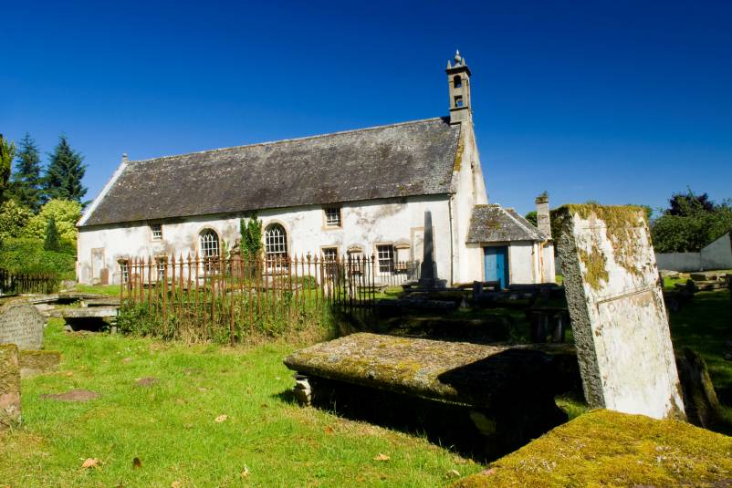
Glossary

Artefact – an object, usually one made by a human being, which has archaeological or cultural significance. At the East Church, this includes coins and many different things that have been discovered after being accidentally lost over the years, often slipping between floor boards. It also includes objects deliberately left over the centuries, sometimes associated with burials within the building.

Aggregate – when used in a building context, aggregate means the material added to a binder, to make mortar. Aggregates can include gravel, sand, broken shells, or crushed brick.

Ashlar- stone worked to have flat faces, and square edges. When used for building, usually laid in horizontal rows, or courses.

Aumbry – a small niche or cupboard, used for storing the vessels for celebrating mass, including ceremonial plates and cups.

Binder – this is the term used for the pastes, or cements, to which other things are added to make mortars. Lime-based binders were used traditionally, with local materials added to them, such as gravel or crushed shells, to make mortars. These are the “glues” between bricks or stones in walls.

Conservation – is the process of caring for something to slow down the natural rate of decay as far as possible. The aim is to make sure people in the future a can enjoy the same things we appreciate now. Conserving a building means changing as little as possible, usually using traditional materials like wood, glass, and lead, and making the building as wind and watertight as possible.

Course – a horizontal row of stones. Sometimes on the outside of a building, there will be a string course – a projecting line of building stones to indicate a floor level, or just to decorate a big block of stone work.

Harl – a coating that (when wet) looks a little like porridge used on the outside of buildings. Harl protects the stone beneath it from rainwater and decay. Made using lime and gravel, it is a traditional, sympathetic finish.

Hatchment - a painted panel, usually with ceremonial significance, or showing family emblems.

Hopperhead – box shaped (usually metal) containers sitting between rhones, and downpipes. Used where a large roof area would create a big flow of water in a downpour of rain, hopperheads create a temporary reservoir, allowing water to drain away more slowly rather than cascading down the walls. Sometimes used decoratively, to display crests, dates, or emblems related to a building or owner.

Mason - someone who works with stone

Masonry - stonework in a building

Mortar – a material that is in a flexible state, which is trowelled into place between stones, and sets there. Doing this job is called pointing. Consists of a binder (the chocolate) and aggregates (the crispies)

Pantiles – S-shaped red clay roof tiles, which slot together. Often found on humble historic buildings in Scotland’s east coast.

Pointing – this is the where mortar can be seen between bricks or building stones. The job of spreading mortar between stones, and smoothing the edges which will be seen when the next stone or brick is placed on top, is called pointing.

Rhones – the Scots building term for gutters, where rainwater from roofs is collected before it flows away into downpipes, or drainpipes. Traditionally made of cast iron.

Rubble - stone used for building walls that hasn’t been worked to flat surfaces. Dry stane dykes (dry stone walls) are built from rubble, without mortar, hence the name, dry.

Further reading and resources

Alston,David
A History of Cromarty East Church
Comprehensive, thorough, and readable account of the church through the centuries. Available as a pdf download from the Scottish Redundant Churches website. The link below goes straight to the history of the church. http://www.eastchurchcromarty.co.uk/history.asp

Gifford, John
Highlands and Islands volume, Buildings of Scotland series.
Scholarly and comprehensive architectural history

Beaton, Elizabeth
Ross & Cromarty, RIAS architectural Guide series.
Paperback, approachable and concise local guide

The Scottish Redundant Churches Trust website
www.srct.org.uk Information about the SRCT, its role, and the churches in its care

The East Church project website
www.eastchurchcromarty.co.uk the SRCT’s project website, with latest information, pictures, and news about what is happening at the East Church.

BBC Restoration Village website for the East Church
http://www.bbc.co.uk/history/programmes/restoration/2006/scotland_cromarty_east_church_01.shtml

Contractors website
http://www.traditionalmasonry.co.uk/ Laing Traditional Masonry – the main contractor for the East Church

Architects
http://www.ldn.co.uk/main.html Architects for the East Church (nothing yet on the website for the East Church, but will follow)

The Cromarty Archive
www.thecromartyarchive.org This website has an on-line library of images of Cromarty and the town’s residents past and present. The archive includes historic photographs of the East Church dating back over 100 years.

www.hughmiller.org

http://www.black-isle.info/Cromarty/history.html
Scottish Lime Centre Trust
http://www.scotlime.org/ Useful background to traditional building materials and techniques

Church Buildings Maintenance in Scotland
www.maintainyourchurch.org.uk
This website is designed to help congregations look after the buildings in their care. It is aimed at ordinary people, and has an excellent illustrated glossary of building terms.

Web based teaching resources

Art Attack
A visit to Cromarty East Church offers rich potential for art activities. The Art Attack website has detailed, step by step instructions with accompanying photographs of the work in progress, for a huge variety of projects, both 2D and 3D, and a huge variety of media and techniques. Making stained glass windows, a maths and art activity is mentioned in the text, but clay, modroc or junk materials could be used to make model buildings, replica carvings, or relief maps, in addition to traditional drawings and paintings.
http://www.hitentertainment.com/artattacK/

The Churches Conservation Trust
This English trust works in a similar way to the Scottish Redundant Churches Trust, caring for very special places of worship. There are a number of excellent teaching resources available to download. Registration is required, but is simple, quick and free! Resources are linked to the English key stages and outcomes, and specific churches. However, themes such as “What was a child’s weekend like 100 years ago?” or, “What Sounds Can You Hear in a Church?” give an indication of the wealth of teaching resources on the site.

http://www.visitchurches.org.uk/

